Website Host

Webhosting Site

**Hostinger** 2

**A2hosting** 4

**GoDaddy** 6

**Greengeeks** 9

**Inmotionhosting** 11

**Bluehost** 13

# **Hostinger**

**Shared Web Hosting Plan**

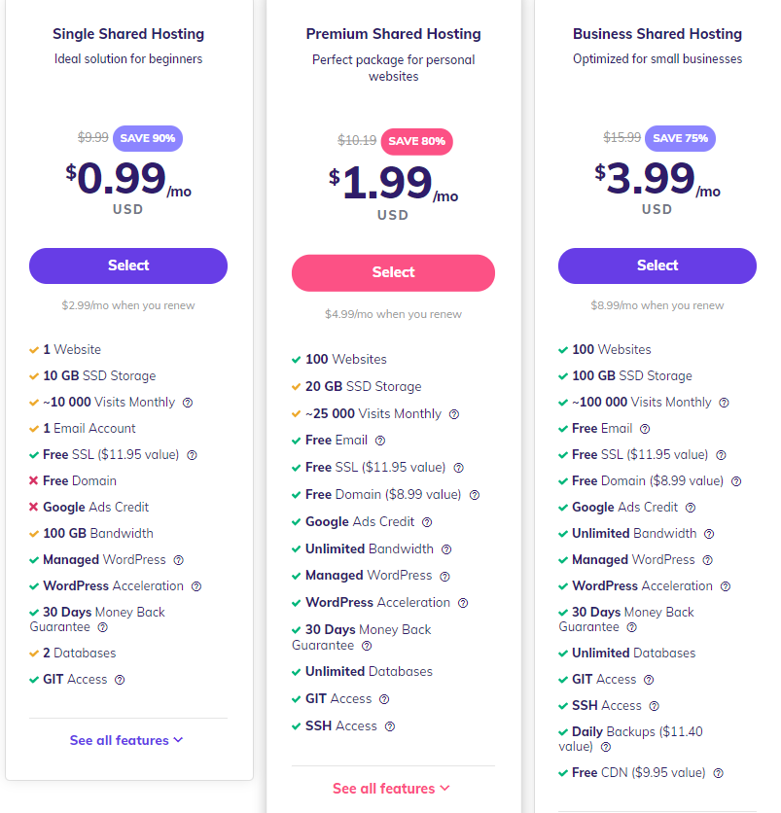Single Shared Hosting Premium Shared Hosting Business Shared Hosting

Total:36$ for 1Year Total:72$for 1Year Total:108$for 1Year

**Link:** <https://www.hostinger.com/web-hosting>

**VPS Hosting**

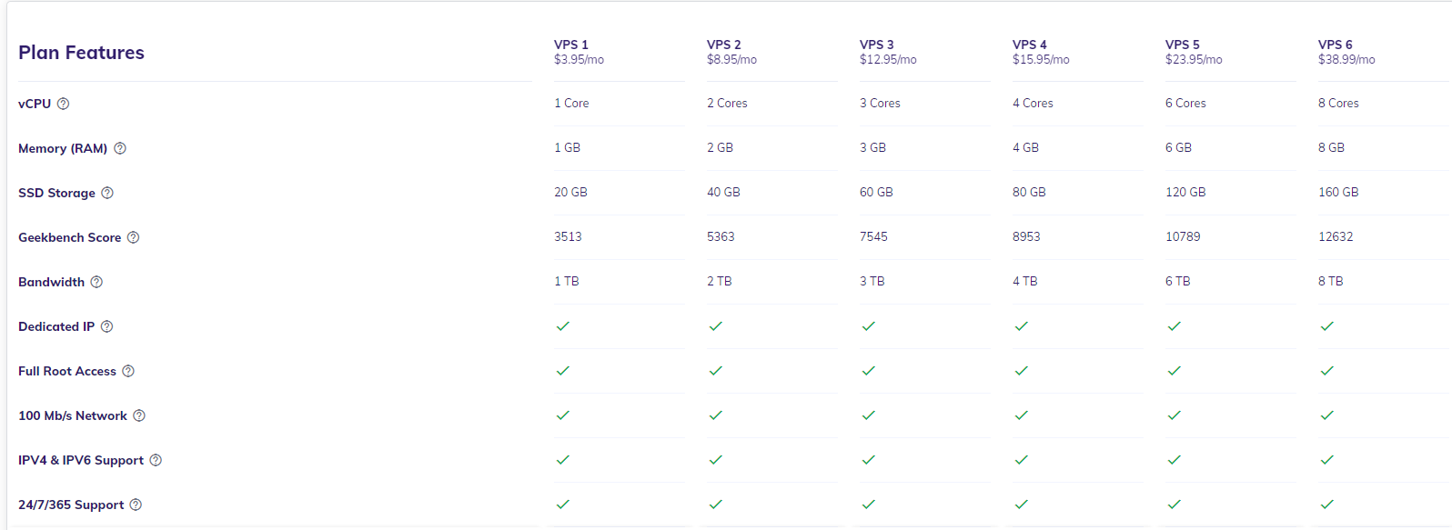

**Link:** <https://www.hostinger.com/vps-hosting>

# **A2hosting**

**Shared Web Hosting Plan**

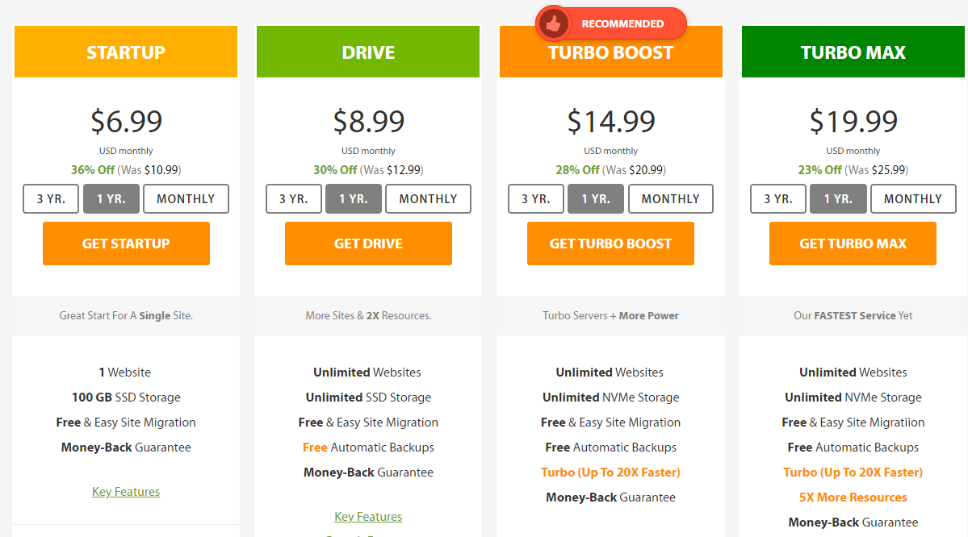

**Link:** [**https://www.a2hosting.com/web-hosting/reviews**](https://www.a2hosting.com/web-hosting/reviews)

**VPS Hosting**

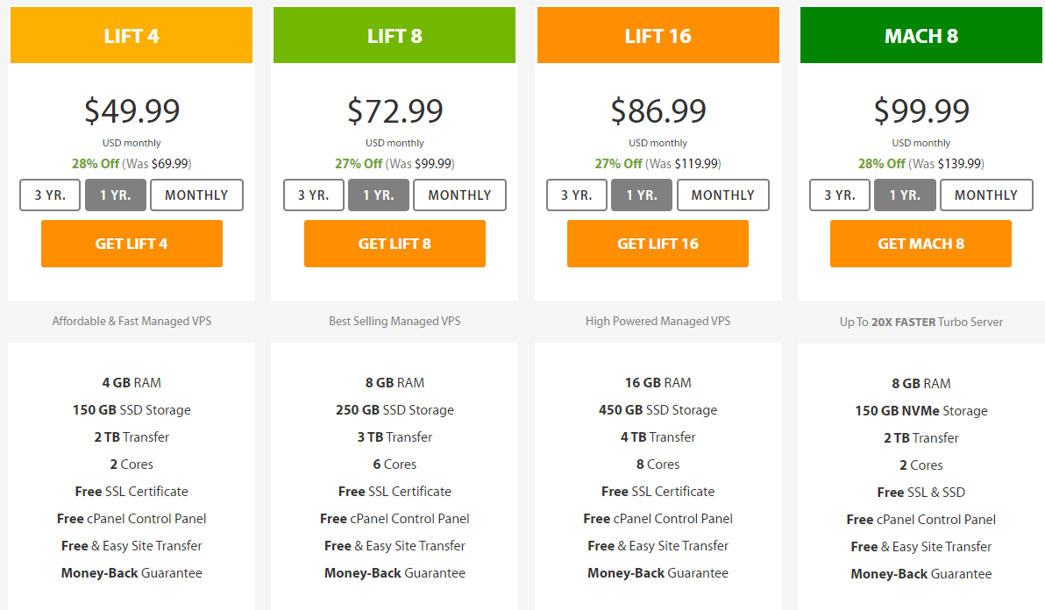

**Link:** [**https://www.a2hosting.com/vps-hosting/managed/reviews**](https://www.a2hosting.com/vps-hosting/managed/reviews)

# **GoDaddy**

**Shared Web Hosting Plan**

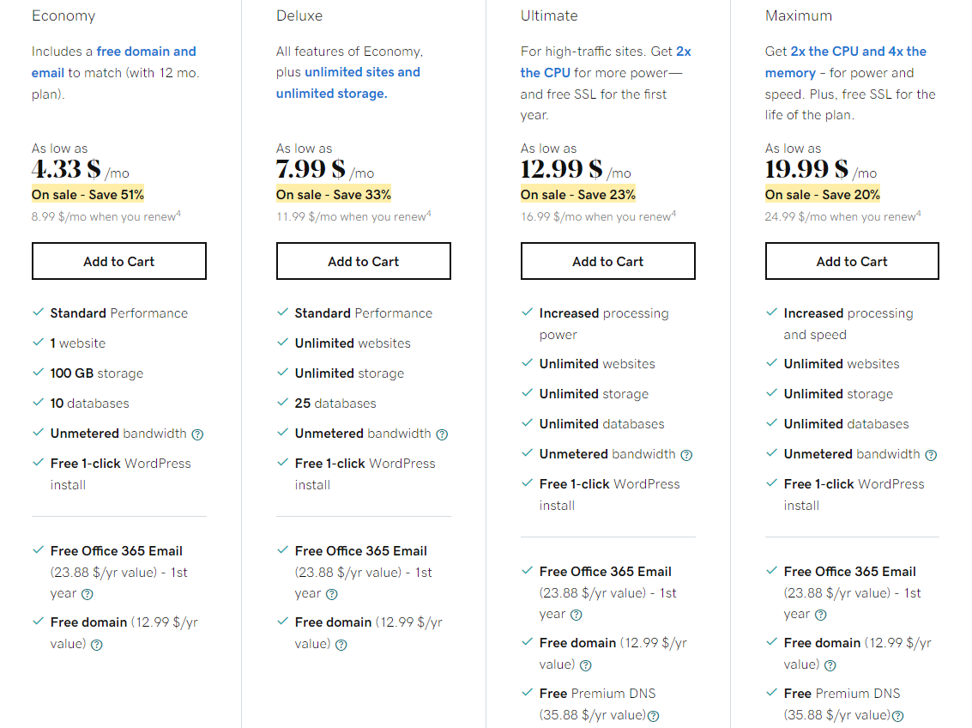

**Link:** <https://ae.godaddy.com/hosting/web-hosting>

**VPS Hosting**

**Standred Ram**

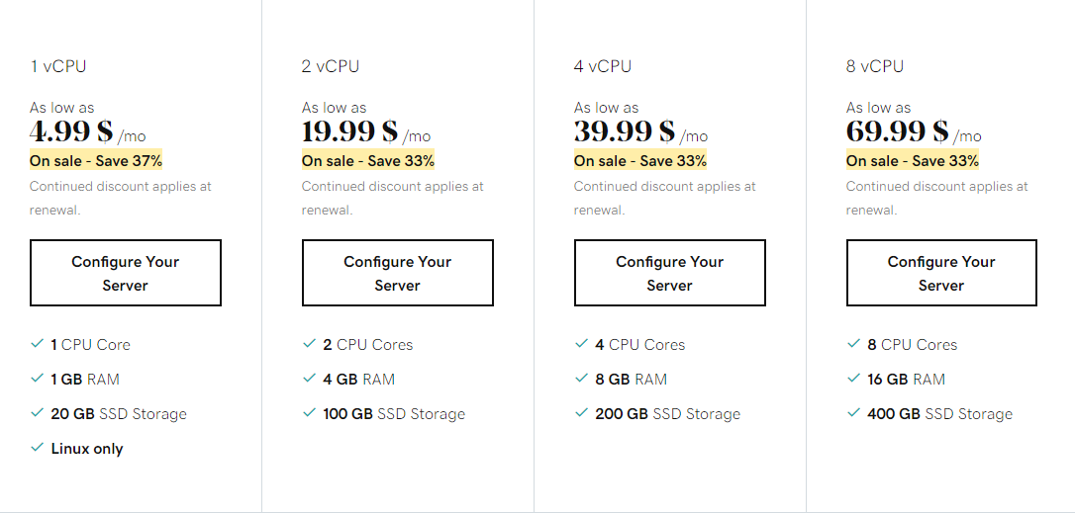

**Link:** <https://ae.godaddy.com/hosting/vps-hosting>

**High RAM**

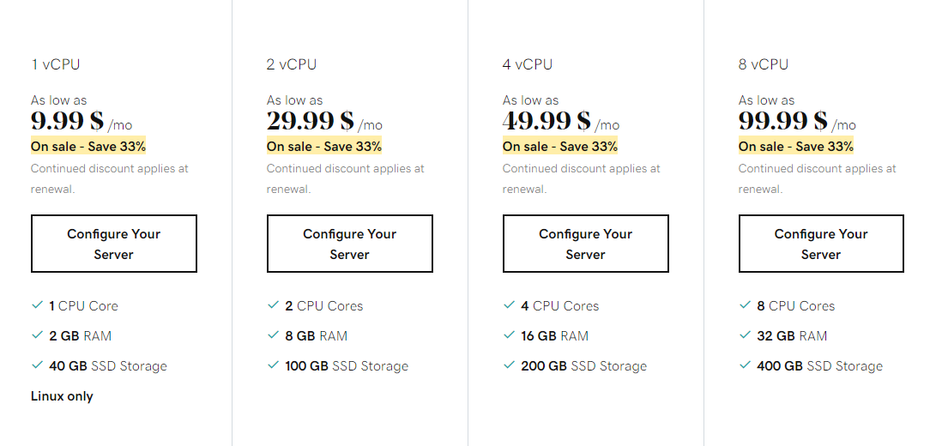

# **Greengeeks**

**Shared Web Hosting Plan**

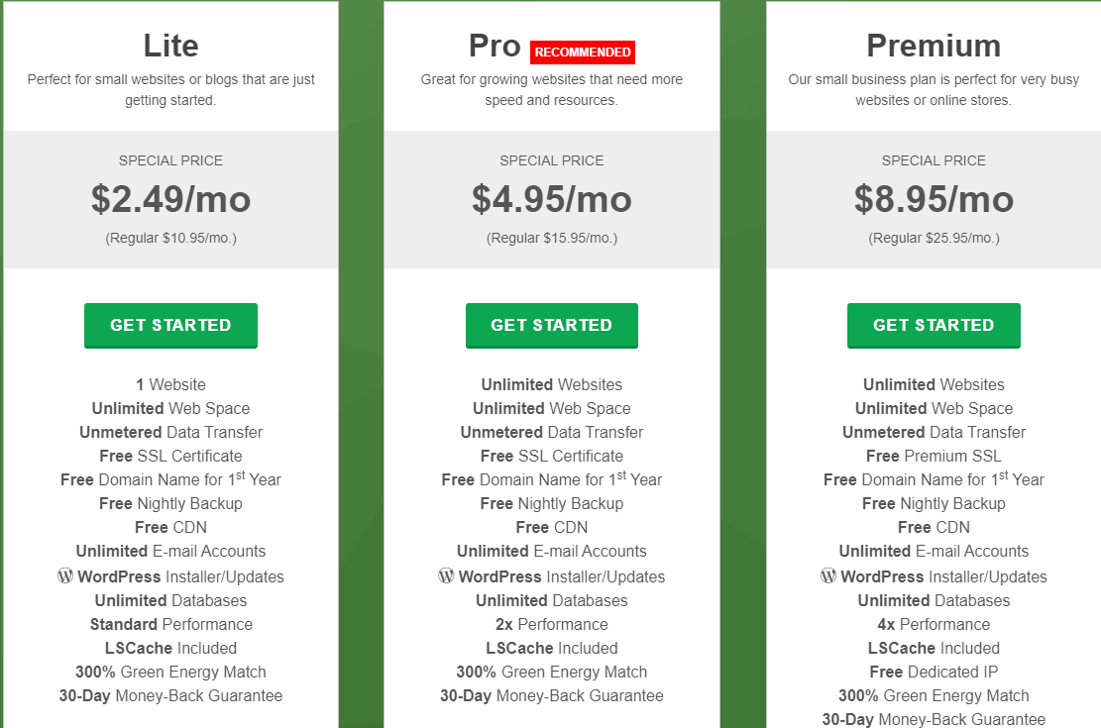

**Link:** <https://www.greengeeks.com/web-hosting>

**VPS Hosting**

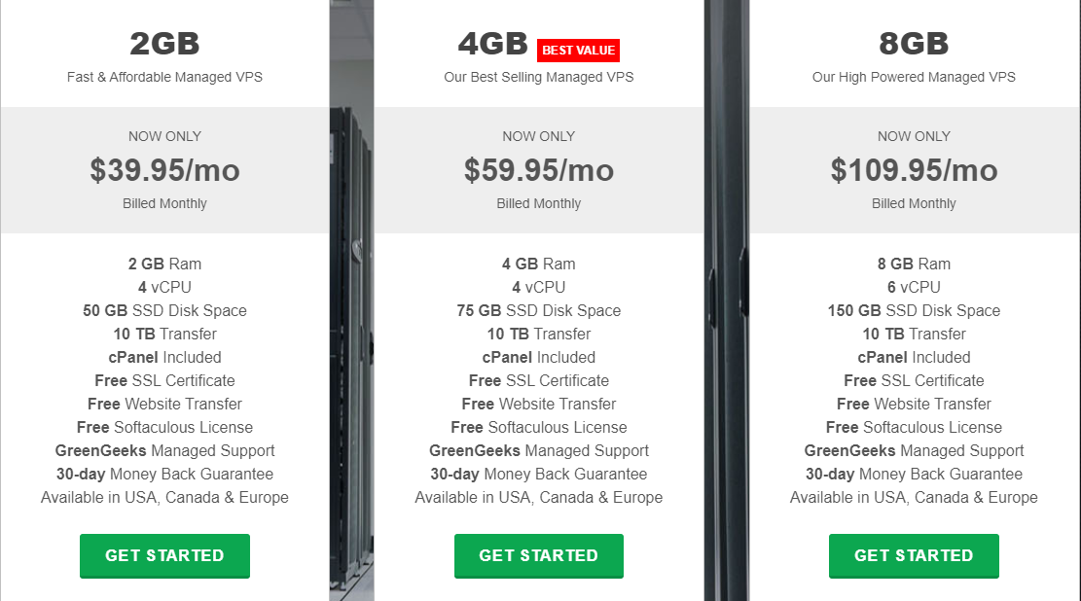

**Link:** <https://www.greengeeks.com/vps-hosting>

# **Inmotionhosting**

**Shared Web Hosting Plan**

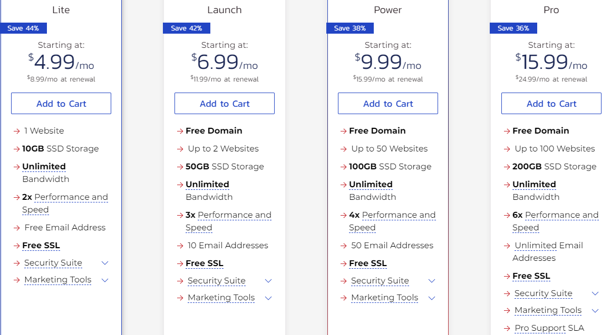

**Link:** <https://www.inmotionhosting.com/shared-hosting>

**VPS Hosting**

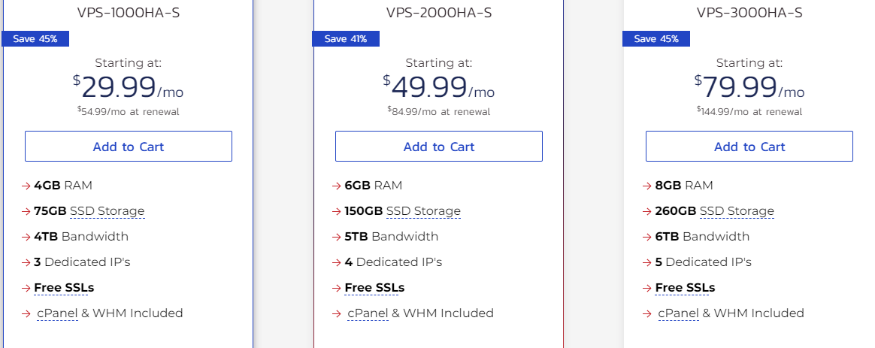

**Link:** <https://www.inmotionhosting.com/managed-vps-hosting>

# **Bluehost**

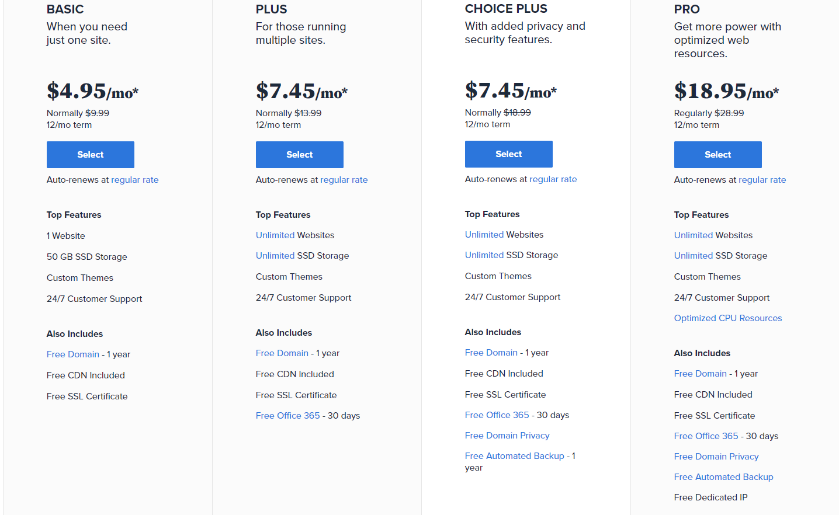**Shared Web Hosting Plan**

**Link:** <https://www.bluehost.com/hosting/shared>

**VPS Hosting**

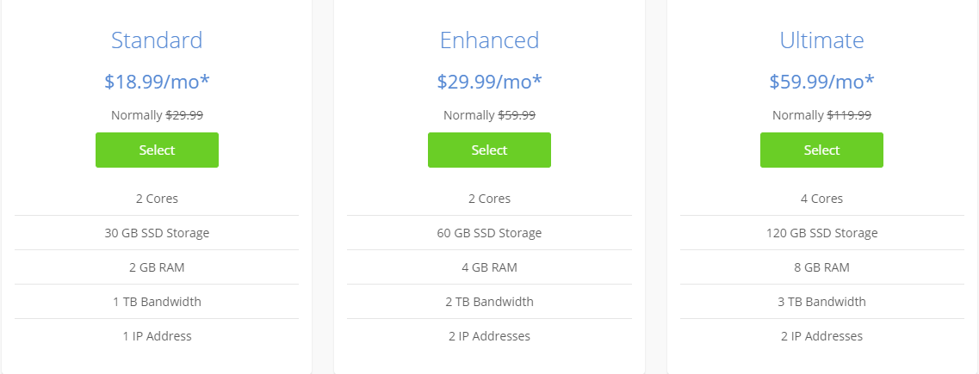

**Link:** <https://www.bluehost.com/hosting/vps>